Title

How to update old definition Laptop with latest AV definition
on open network

Prepared By

Dnaneshwar Dhembare

Date: 12-04-2016

Version 1.0

Document History

Date | Author | Revision | Description
12-04-2016 |  | Version 1.0 | Document Creation

Approved By: | Tata Business Support Services Limited
Ajay Kumar

Distribution List
Name | Department | Company | Rights

Security Classification: Tata BSS Restricted.

- Connect your Laptop to Internet.

- Open Symantec Endpoint Protection
Click on Start-All Programs-Symantec Endpoint Protection-Symantec
Endpoint Protection

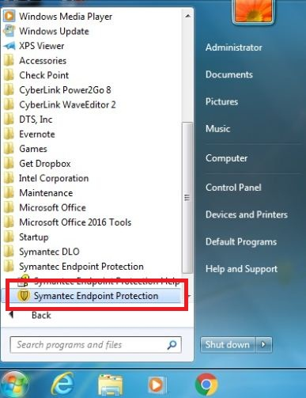

- Click on LiveUpdate…Option as per below screen capture

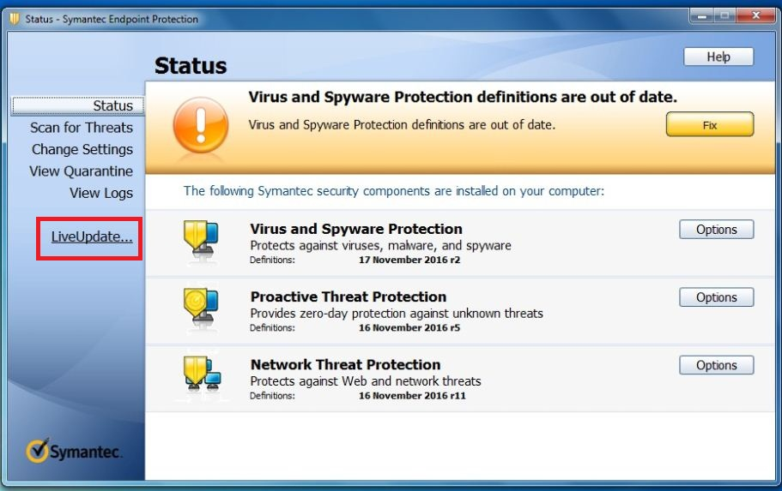

- Client/AV will download the update packages automatically.

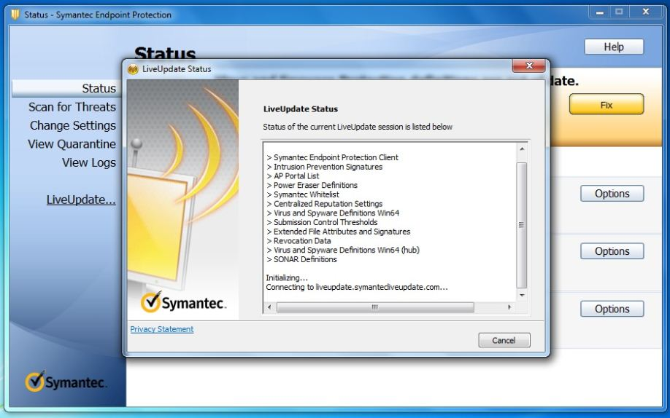

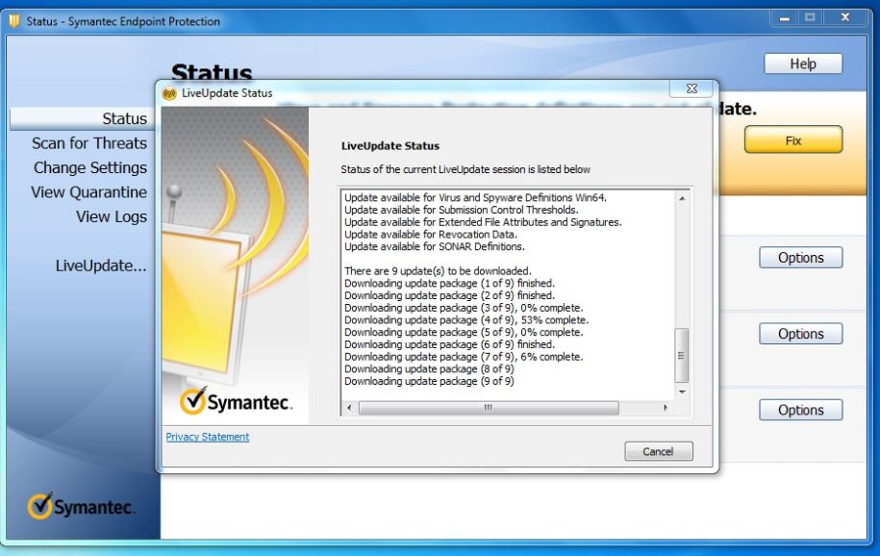

- Click on close option once downloading is completed, as per below screen capture

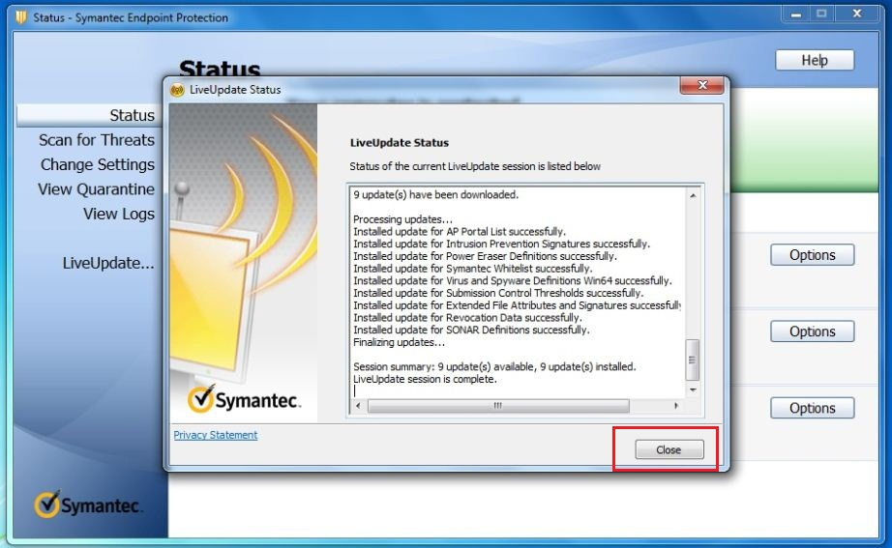

- Your Symantec Endpoint Protection is now up to date

